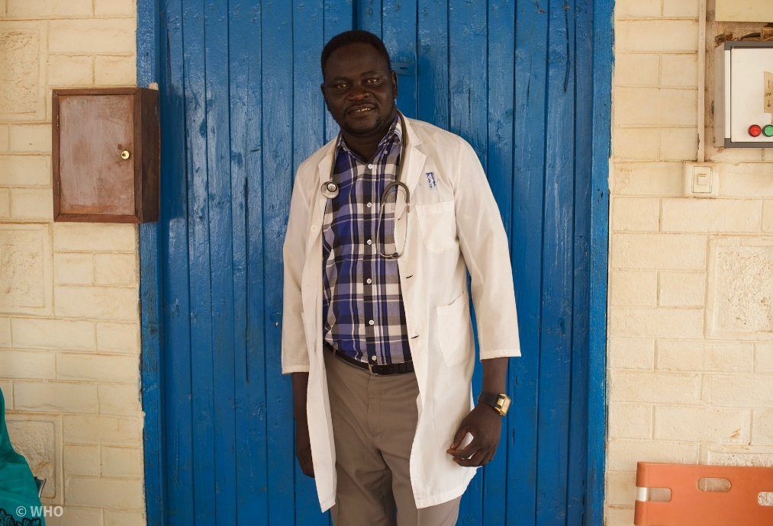
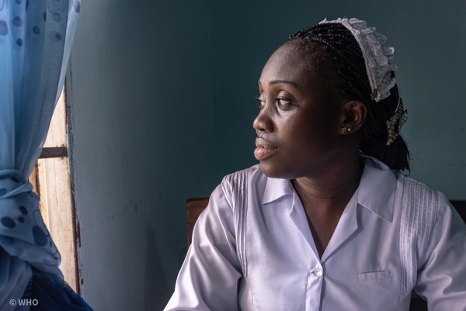


Key findings of need based HWF requirements to address Africa’s disease burden and demographic evolution
Health Work Force (HWF) Team (HWF)
May 2024
Analytical
Fact Sheet

Rationale
The African region has experienced a 19% increase in health workforce numbers from 4.3 million in 2018 to 5.1 million in 2022 with the Regional Implementation Framework on Human Resources for Health Workforce 2030, but low health worker densities and significant disease burdens have been observed. Policymakers are trying to evaluate the Health Workforce (HWF) against population health needs to address the critical gaps and develop an effective workforce to address the region’s diverse health challenges. This need-based analysis report is part of the systemic process to understand the context.

Key findings
- 9.75 million as current health workforce need, 11.8 million will be required by 2030
- 6.1 million, as anticipated shortage of HWF by 2030, with significant shortages in doctors, nurses, midwives, pharmacists, and dentists.
- 47% of communicable disease workforce demand currently but decreasing trends. 37% of noncommunicable diseases demand but increasing trends. 16% of demand contributed to injuries but increasing trends.
- Less than 43% of workforce coverage in 2022, more than 49% will be improved (projected) by 2030. Workforce density and stock have also increased significantly since 2013.
- In 2022, US$20.85 billion (57%) of funding achieved out of US$36.3 billion required
- Total funding needed by 2030 is US$120.4 billion (training: US$22.58 billion; employment: US$97.83 billion).
- 49% of countries can enhance funding by prioritising within existing health budgets.
- 51% should seek efficiency gains and better prioritisation within government expenditures.

Background
The 2021 Universal Health Coverage (UHC) monitoring reported substantial improvements in service coverage from 2000 to 2021, although the African Region still lags with significant unmet health needs. It has been striving with disparity. Over the past two decades, substantial investments in training and educational infrastructure have markedly increased the number of health professionals trained annually, significantly boosting HWF. A critical shortage of health workers remains, with projected deficits varying greatly depending on the estimation methods and quality of data. This study addresses the urgent need to evaluate the health workforce against the region's disease burden, aiming to determine the required workforce and necessary investments to meet health needs effectively.

Brief Overview of concept and methodology
A Comprehensive methodology is applied to assess three key aspects: HWF needs based on population health, the current HWF stock and supply, and the investment required to bridge any identified gaps. Utilising The previously validated models is adapted, firstly defines HWF needs by aligning them with the population’s inherent 'need for health services'. This need is further interpreted through the lens of (UHC) aspirations.
The conceptual framework explores these needs by considering demographic data, disease prevalence, and required health interventions. This provides inputs to project HWF requirements. The HWF planning will be not only responsive to the current disease burden but also aligned with equitable service delivery.
The pool of qualified health workers (known as the overall stock) comprised ‘right to practise’ practitioners with various employment and unemployment statuses. A stock and flow model is formed to analyse workforce dynamics, factoring in both inflows from training and immigration, and outflows like retirement, emigration, and career changes.
The financial implications are assessed by comparing HWF needs with the existing and anticipated supply to identify any shortages, surpluses, or balances. This involves estimating the costs of resolving these mismatches and comparing them with the financial resources available for health workforce planning and development. Please click this link to the full conceptual framework.

Key Findings
3.1 Regional needs-based requirements for health workers (2022-2030):
- Initially requiring 8.7 million health workers in 2022, the African Region will need 10.6 million by 2030. This includes a significant representation by community health workers, with numbers rising from 1.1 million in 2022 to 1.3 million by 2030.
By Type of HWF,
Medical doctors:
- Estimated 1 million medical doctors needed in 2022, with an expected 24% increase to 1.3 million by 2030. Among them, 47% were needed as generalist medical practitioners in 2022, with a slight decrease to 46% by 2030.
Pharmacists and technicians:
- Around 160,000 pharmacists needed in 2022, with a projected increase of 16% to 185,000 by 2030.
- 128,000 pharmaceutical technicians and assistants needed in 2022, with their numbers expected to rise by 21.4% to approximately 155,334 by 2030.
Nursing and midwifery personnel:
- 5.1 million nursing personnel needed in 2022, with numbers projected to increase by 22% to 6.3 million by 2030.
- 880,000 Midwifery personnel needed in 2022, expected to grow by 19% to reach 1 million by 2030.
Laboratory personnel:
- 343,000 laboratory personnel needed in 2022, with a 24% increase projected, increasing figure to 423,000 by 2030.
Community Health Workers (CHWs):
- 11% of the overall HWF requirement for CHWs in 2022, totalling about 1.1 million. It is anticipated to rise by 19% to 1.3 million by 2030.
3.2 Estimated densities per 10,000 population for selected occupations:
- Country-specific HWF density estimates were derived, allowing for nuanced planning and dialogue tailored to each country's economic conditions and health service demands.
- The analysis shows variations in HWF needs per 10,000 population across countries.
Type | Highest country | Highest density | Lowest country | Lowest density
Dentist | Eswatini | 1.32 | Seychelles | 0.68
Generalist Medical Practitioners | Mauritius | 7.3 | Eritrea | 4.35
Specialist Medical Practitioners | Mauritius | 12.36 | Burundi | 5.04
Nursing Professionals | Mauritius | 86.94 | Madagascar | 31.74
Midwifery Personnel | Sao Tome and Principe | 14.1 | Mauritius | 6.88
Pharmacists | Mauritius | 3.94 | United Republic of Tanzania | 0.94
Laboratory Personnel (Medical and Pathology Laboratory Technicians) | Burundi | 6.04 | Eritrea | 1.04

Figure 1: Density of estimated HWF needs-based requirements
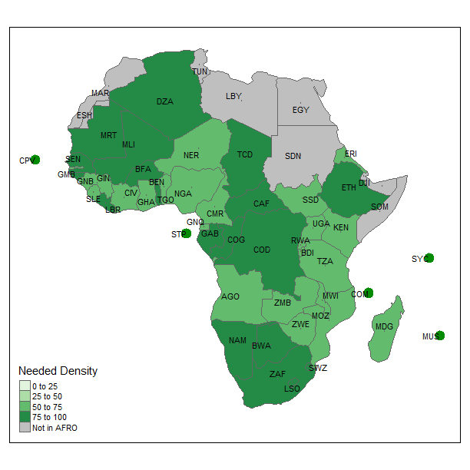
3.4 Rate of increase in the need for health workers:
- The demand for health workers in the African Region is expected to grow significantly, outpacing population growth, with variations observed across different countries.
- The highest regional increases were noted in Burundi (29.7%), Mauritania (42.9%), Namibia (43.7%), and Rwanda (45.9%).
3.5 Impact of evolving disease burden on needs-based HWF requirements:
- Changes in disease prevalence significantly influence the increasing need for health workers, with communicable diseases, NCDs, and injuries driving specific workforce demands.
- A regression analysis showed that population growth accounts for only 33% of the variations in the need for health workers, while 67% is influenced by other factors including disease burden, with communicable diseases contributing 47%, NCDs 37%, and injuries 16% of the requirements.

4.1 Stock and density of health workers
- From 2013 to 2022, the number of health workers in the African Region tripled from 1.6 million to 5.1 million. Nurses made up 33.3% of the workforce, CHWs 16.7%, and medical doctors 7.2%.
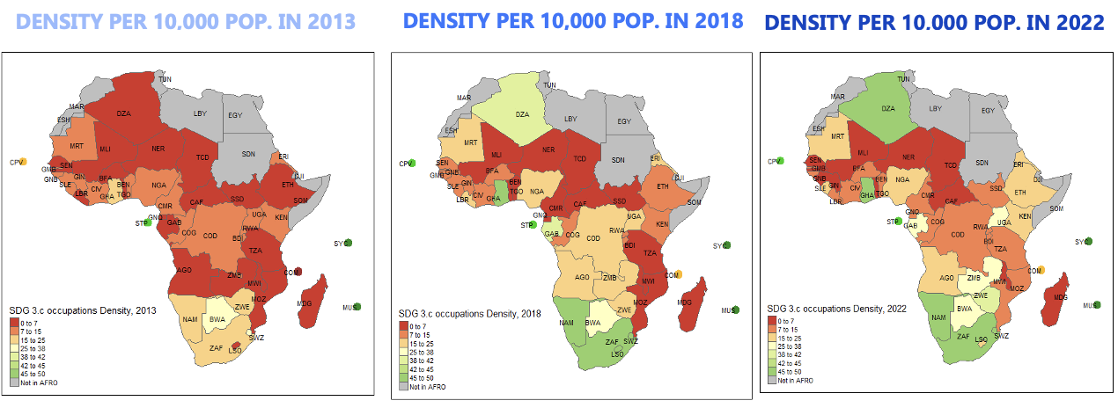
Figure 2. Density of SDG 3.c tracer occupations per 10 000 population 2013–2022. *SDG 3.c tracer occupations are doctors, nurses, midwives, dentists and pharmacists combined
Source: WHO NHWA data – Latest years data used. Accessed 2 February 2024
4.2 Projected HWF stock 2026 and 2030
- The African Region is expected to increase its health workforce by nearly 1.7 million by 2030, with a projected total of 3.5 million for SDG 3.c tracer occupations (medical doctors, nurses, midwives, pharmacists, and dentists), marking a 37% increase over eight years.
- Kenya, Liberia, Seychelles, and South Africa, are expected to experience a decline in their stock of practicing health workers, particularly among nurses and midwives.
- Conversely, 30 countries (64% of the region) are expected to see their HWF grow by more than 30% by 2030.
4.3 Need-based HWF shortage in the African region
- In 2022, a need-based shortage of 5.6 million health workers.
- Projected to increase to 6.1 million by 2030. By then, the stock is expected to cover only 48% of the required health workforce.
- The detailed analysis showed that, in 2022, the stock only covered 11.5% of the regional need for specialist medical practitioners, 24.1% for nurses, 38.1% for midwives, and 31.5% for dentists. These disparities are projected to persist into 2030, with varied coverage rates ranging from 36% for nurses to 51% for dentists.
- African Region will need to at least double its 2022 HWF stock
4.4 Scenario analysis for addressing the needs-based HWF shortage in 2030:
Scenario analysis suggests that improving training output and absorption rates could significantly mitigate the projected needs-based shortage, potentially reducing it by up to 26% by increasing training outputs to 40% and absorption rates to 90%.

5.1 Ballpark estimates of potential financing envelope for HWF employment
  - In a "business as usual" scenario, the projected HWF budget for the African Region could grow from US$20.85 billion in 2022 to US$31.81 billion by 2030. Public sector funding alone might growth from US$14.17 billion in 2022 to US$20.67 billion by 2030.
  - Under "HWF prioritization" and "Health Prioritization" scenarios, the financing envelope could potentially increase to US$44.86 billion and US$55.32 billion by 2030, respectively, indicating substantial growth with strategic prioritization.
5.2 Overall funding gaps for HWF Investments to reduce shortage by half
  - The region faced a significant funding deficit of 43% in 2022, translating to an unemployed health worker rate of 27% based on a subset of countries. To cut halve of the current health worker shortage by 2030, an estimated US$120.41 billion is needed, with 18.75% for training and 81.25% for employment.
  - The investments required represent less than 2% of the GDP of countries in the region, indicating a feasible financial commitment relative to economic sizes.
5.3 Current levels of prioritization for health and HWF investments
  - Countries in the African Region spend an average of 4% of GDP on health, with 43% of health expenditure dedicated to HWF remuneration. The level of prioritization varies widely, with nearly half the countries needing to better prioritize HWF within their health budgets.
  - Four groups of countries are identified based on their prioritization levels, suggesting different strategies for enhancing HWF investments, ranging from better allocation within existing budgets to advocating for increased health budgets or external aid.

Discussion of Key Findings:
The paradoxical surplus of health workers, characterised by a 27% unemployment rate, complicates the crisis further, emphasizing the need for not just training but effective employment and equitable distribution strategies.
Financial projections suggest that US$120 billion is needed over the next eight years to address this situation, with current funding anticipated to grow from US$20.85 billion in 2022 to US$31.81 billion by 2030.

Strengths and Limitations:
This analysis is the first of its kind to use nuanced, country-specific data to assess health workforce requirements across the region. It integrates a broad range of health interventions and expert opinions to provide a detailed view of HWF needs.
Limitations include reliance on modelled data and expert opinions, which introduces subjectivity and potential inaccuracies in workload and productivity measures.

Conclusion and Policy Options:
To mitigate the anticipated shortage and enhance health workforce capacity, countries need to more than double their current HWF stock, requiring significant investment, estimated at nearly 2% of GDP, focusing on both training and employment of health workers.
Policy options include accelerating HWF training, particularly at the primary care level, developing integrated national HWF investment plans, optimizing skill mix, and transforming health profession education to be competency-based.
Employment strategies should emphasize efficiency and equity, such as engaging in multisectoral policy dialogue, establishing wage harmonization, and strengthening health workforce analytics to support evidence-based decision-making.

References
WHO, Need-based health workforce requirements to address Africa’s disease burden and demographic evolution: implications for investing in the education and employment of health workers, 2022 – 2030, a technical paper, 2024.

Sources
The Integrated African Health Observatory supported the production of the factsheets.
Photography:
Left photo: A obstetrician-gynecologist during a weekly referral clinic at Wau
Teaching Hospital, Location: Wau Teaching Hospital, South Sudan, © WHO
Right photo: Portraits of a nurse, location: Plateau State Specialist Hospital in Jos, Nigeria. © WHO
Check out our other Fact Sheets in this iAHO country health profiles series:
https://aho.afro.who.int/country-profiles/af
Contact us at: iAHO@who.int

Connect with us on LinkedIn: https://www.linkedin.com/company/iaho/

The fact sheet was produced by Wai Phyo Thant,

